Long Division Foldable
For Interactive Math Notebook

Is long division easy? Does McDonalds Serve Burgers?
Divide
Multiply
Subtract
Bring Down
With this printable you will be able to give your students step by step instructions for long division while also creating an interactive math notebook foldable.
The four tabs will need to be cut out and the detailed steps attached underneath.

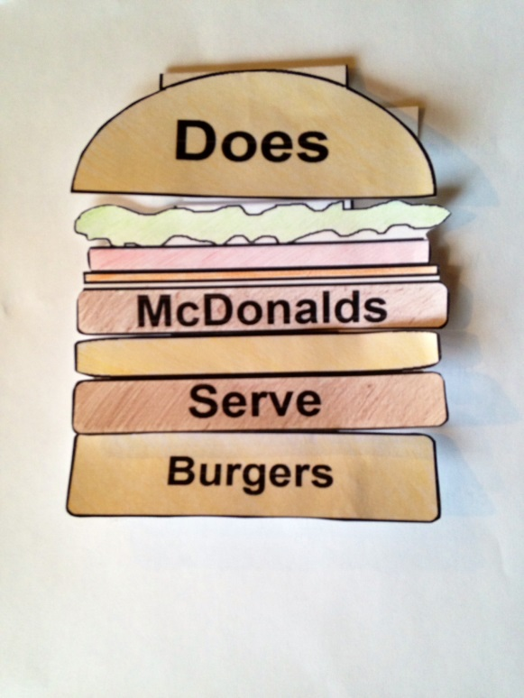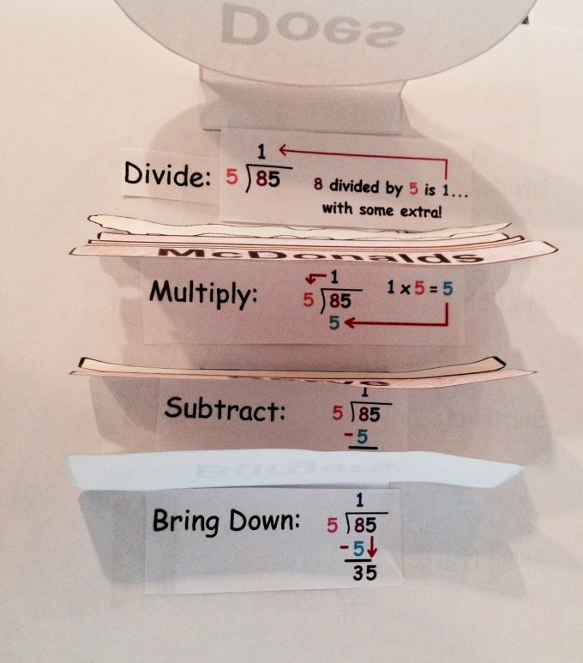

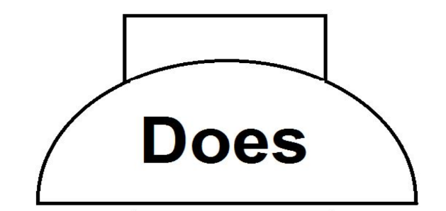

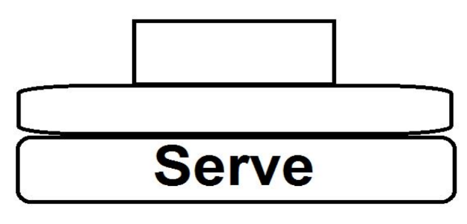

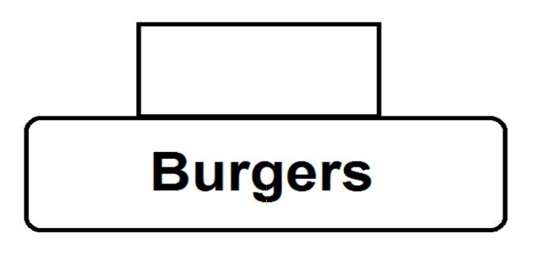

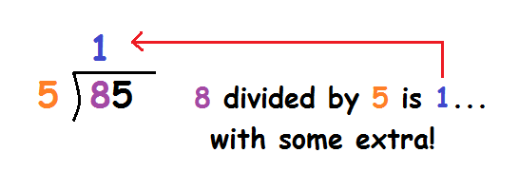
Divide:

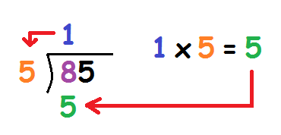
Multiply:

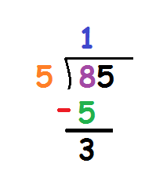

Subtract:

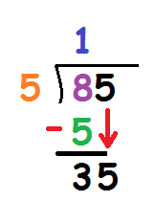
Bring Down:

